Student name: Rocco Given Visagie

Student number: 220343527

Project Information: Request for Submission: T2 Individual Report – Deliverable 2

Section: ERD and Business Rules

These are screenshots of my entities for the ERD. I am doing the user page and the review page.
This is the link to the full ERD.
https://lucid.app/lucidchart/7344477d-ad94-40a5-a179-27c696ec4515/edit?viewport_loc=970%2C352%2C2154%2C950%2C0_0&invitationId=inv_d701e92d-461f-4a47-b7e3-9ff7489016f5

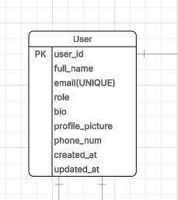
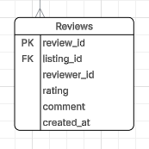

User Page Business Rules

User Registration & Authentication
- A user must register with a unique email address and username.
- A user account cannot be created without a valid password.
- Passwords must be securely encrypted before storage.
- A user can only log in if their account is active.
- A user may reset their password using email verification.
- A user can have only one profile linked to their account.
- A user role must be assigned during account creation (Student or Admin).
User Profile Management
- A user may update their profile information at any time.
- A user profile may include a profile picture, bio, university, faculty, and year level.
- A user cannot access another user’s private account settings.
- Profile updates must automatically update the updated_at field.
User Marketplace Activity
- A user can create multiple listings.
- A user can save multiple listings to favourites.
- A user can participate in multiple chats.
- A user can send multiple messages in chats.
- A user may place bids on listings if bidding is enabled.
- A user can receive multiple notifications.
- A user may purchase multiple marketplace or merch items.
User Restrictions & Validation
- A suspended or banned user cannot create listings or send messages.
- A user cannot review their own listing.
- A user must be logged in to interact with marketplace features.
- Users must comply with marketplace content policies when creating listings.
Review Page Business Rules
Review Creation
- A review can only be created after a completed order or transaction.
- A review must be linked to a valid order and listing.
- A review must have one reviewer and one reviewee.
- A user cannot submit more than one review per completed transaction.
- A review must include a rating value.
- Rating values must be between 1 and 5.
Review Content Validation
- Review comments cannot be empty if a low rating is given (1–2 stars).
- Reviews containing offensive or prohibited content may be removed by admins.
- Reviews cannot include spam, external advertisements, or false information.
- A review must contain a valid creation timestamp.
Review Permissions
- Only authenticated users may submit reviews.
- Users can only edit or delete their own reviews.
- Admins may moderate, hide, or remove inappropriate reviews.
- A review cannot be modified once the review period expires.
Review Relationships
- One user can receive many reviews.
- One user can write many reviews.
- One listing can have many reviews.
- Each review belongs to exactly one listing and one reviewer.
Review System Integrity
- Average listing ratings must automatically recalculate when reviews are added or removed.
- Deleted users’ reviews may either remain anonymized or be removed according to platform policy.
- Fake or duplicate reviews detected by the system may be flagged for moderation.
- Reviews contribute to seller reputation and trust scoring within the marketplace system.

